**Session 6 – Kubernetes Networking Lab**

**Clean up old clusters**

Delete existing cluster if it exists

% kind delete cluster --name tamlab

**Create a Kubernetes v1.20.2 cluster with KIND**



First, make sure you are logged into docker hub to pull the new kubernetes image

Use your dockerhub username and password to authenticate

% docker login

Authenticating with existing credentials...

Now, let's create a KIND cluster using a specific version of Kubernetes (v1.20.2) in this case

% kind create cluster --name tamlab --config kind-config.yaml --image kindest/node:v1.20.2

You should get something similar to the following output:

Creating cluster "tamlab" ...

✓ Ensuring node image (kindest/node:v1.20.2) 🖼



⢄⡱ Preparing nodes 📦 📦 📦

✓ Preparing nodes 📦 📦 📦

✓ Writing configuration 📜

✓ Starting control-plane 🕹️

✓ Installing CNI 🔌

✓ Installing StorageClass 💾

✓ Joining worker nodes 🚜

Set kubectl context to "kind-tamlab"

You can now use your cluster with:

kubectl cluster-info --context kind-tamlab

Note: if you get the following error, keep trying! Docker is throttling requests

Error response from daemon: received unexpected HTTP status: 503 Service Unavailable

Let’s view the available clusters

* You should see tamlab as one of the clusters

% kind get clusters

Switch contexts commands

* If you have more than one cluster, the context tells you which cluster is currently the “active” cluster. Any “kubectl” commands you use work with the current active cluster.

% kubectl config get-contexts

% kubectl config current-context

% kubectl config use-context kind-tamlab

* Note: this was previously shown as “set-context” which does not work. You need to “use-context”

#or set explicitly in kubectl command

% kubectl --context kind-tamlab

**Container to Container messaging**

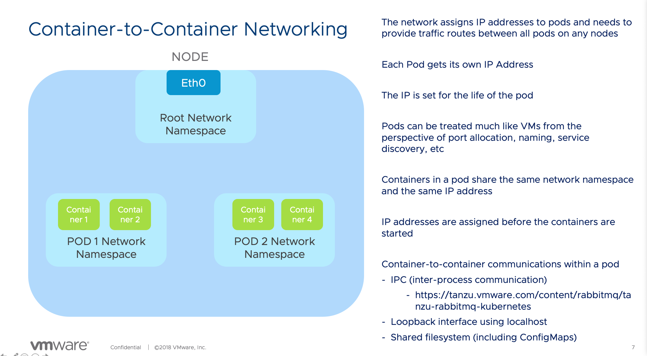

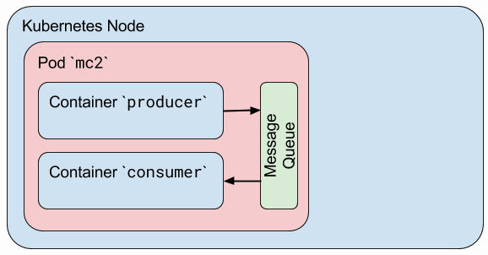

This example shows you how containers communicate using inter-process communications and a message queue (see diagram above).

Let’s take a look at the ipc.yaml file:

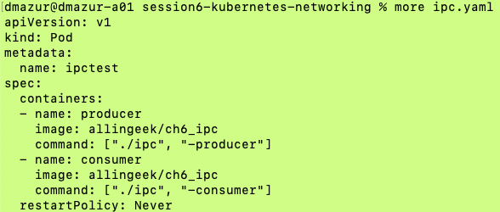

The yaml shows that we are creating a Pod named “ipctest”. In the pod, we are creating two containers, one the “producer” and the second the “consumer”. The producer will send a message to the consumer via a message queue and the consumer will receive the message. Note the restartPolicy in the yaml file only allows the pod to be run one time (Never restart). Let’s try it…

% kubectl apply -f ipc.yaml

Pod/ipctest created

% kubectl describe pod/ipctest

* At the bottom, you should see something similar to:

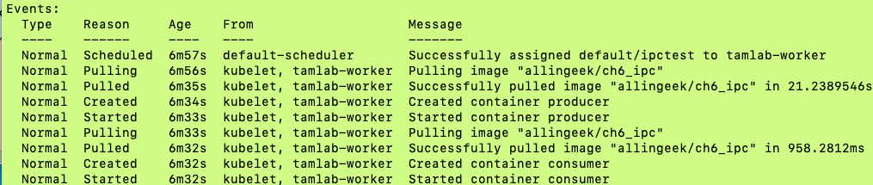

* Note the container images were “pulled” and the containers were started. Also, note the pod (and containers) were assigned to the node “tamlab-worker”
* Now let’s look at the logs for the producer and consumer containers

% kubectl logs ipctest -c producer | more

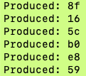

% kubectl logs ipctest -c consumer | more

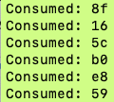

You can see the Producer container sent message “8f” to the Consumer container which received message “8f”

* It’s a good idea to clean up…

% kubectl delete pod/ipctest

**Services Background Slides**





**Demo the Service/ClusterIP (internal load balancer)**



We will create a deployment, named “backend” with (3) replicas

% kubectl apply -f 01hello-deploy.yaml

Let’s look at the yaml file used to create the Service. Note the service name is “hello” and the type is “ClusterIP”. Port is 80 and targetPort is http (which maps to port 80). The default protocol for a service is TCP.

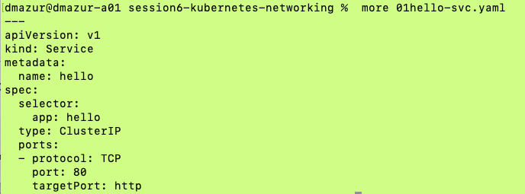

% kubectl apply -f 01hello-svc.yaml

% kubectl get all

* note service type and internal IP
* what subnet is the service on vs the pod?

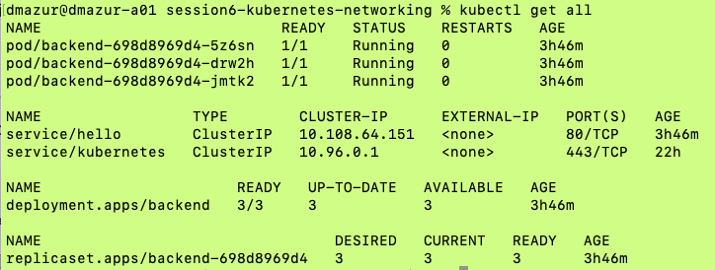



% kubectl describe pod/backend-698d8969d4-5z6sn

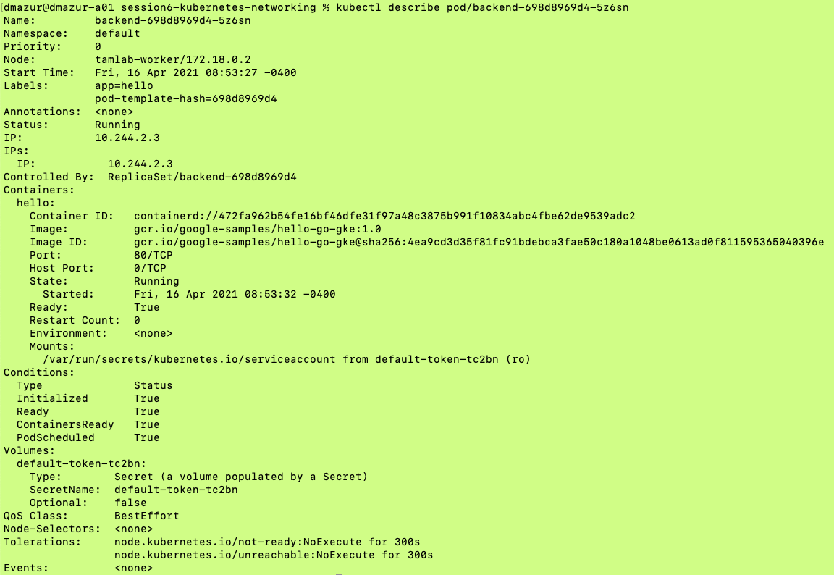



* note that the container port is 80 (i.e. the targetPort) and the port for service/ClusterIP is 80

Let’s forward the service port 80 to port 8080

% kubectl port-forward pod/backend-698d8969d4-5z6sn 8080:80

#open new command window and run the curl command

% curl localhost:8080

{"message":"Hello"} <- once the service was accessed, this message was output by the backend container

In that same second command window, show the output from a ubuntu pod accessing the service

Deploy a ubuntu pod for network and curl tests

% kubectl run my-shell -it --image ubuntu -- /bin/bash



Install the curl package into ubuntu

# apt update

# apt install curl

Access the service from ubuntu pod

* + The hello service is a load balancer in front of the 3 replica pods
  + We are in the same namespace so don't need FQDN

# curl hello:80

“message”:”Hello”}

# exit

Go back to the first command window and do a <ctrl> C to end the session

**Demo the Service/NodePort (expose the service on a specified port on each Node)**



Take a look at the current hello service (note type=ClusterIP)

% kubectl get svc



Now, let’s look at the 01hello-svc2.yaml file:

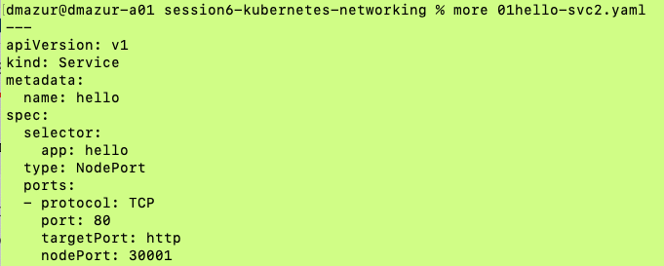

* Note: type is now NodePort and we added nodePort: 30001 at the bottom

We do not need to delete the running service. We modified the config in the new yaml file and we can “apply” the new yaml over the previous service

% kubectl apply -f 01hello-svc2.yaml

% kubectl get svc

- Note: now Type=NodePort and the Port is 80:30001



Show the output when you access the service via the nodePort

* Note: In most environments, the command would be: "curl <K8s node IP>:30001"
* KIND is forwarding the port from the docker K8s container to localhost

% curl localhost:30001

{message”:”Hello”}

**Show how coreDNS works**



Let’s look at the pod for coreDNS (running in the kube-system namespace)

% kubectl get pods -n kube-system –output=wide

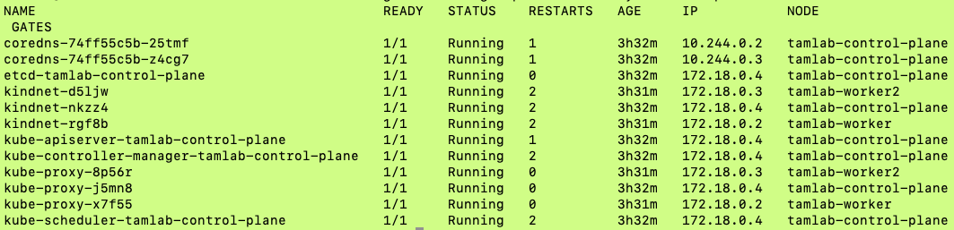



Note:

* This shows you which pods are running on which node
* Kube-proxy is running on all three nodes
* *There are (2) coreDNS replicas for high availability. You can scale this up or down in the deployment for coreDNS*

Example of using coreDNS to access a service named hello in the local namespace (default)

% curl hello

* Note: I’m having trouble getting this to run correctly in KIND. If anyone figures it out, let me know!

Here’s how to get the default cluster-domain name

% kubectl cluster-info dump –output=yaml | grep service-account-issuer



* You can see the cluster-domain is cluster.local

Also, one note on using ping…you can’t ping a Kubernetes service! Ping doesn’t support the use of ports and we access a service using ports. You can use “curl” or “wget” instead.

**Istio demo**



NB – istioctl is too big (>100MB) to save to GitHub. Please copy the file from the session recordings link into istio-1.8.2/bin if you’d like to follow this lab

#export istioctl path

% cd /istio-1.8.2

% export PATH=$PWD/bin:$PATH

% which istioctl

* You should see something similar to:
* /Users/dmazur/go/src/gitlab.eng.vmware.com/atauber/tam-modern-apps/session6-kubernetes-networking/istio-1.8.2/bin/istioctl

#install istio into cluster - this uses modified demo profile

* Modifications are highlighted in red

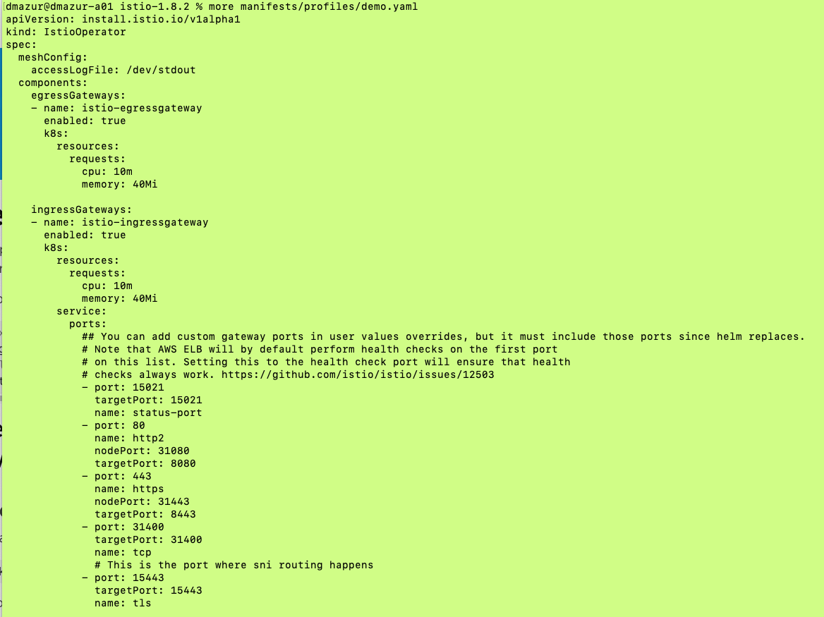



% istioctl install -f manifests/profiles/demo.yaml



We created a new namespace “istio-system”

% kubectl get ns

View everything running in the new namespace

% kubectl get all -n istio-system

#add namespace label so that new pods will get the istio sidecar

# any pods installed into default namespace will have the istio sidecar container injected into the pod

% kubectl label namespace default istio-injection=enabled

This next section installs a sample application called “Bookinfo”. This example deploys a sample application composed of four separate microservices used to demonstrate various Istio features. The application displays information about a book, similar to a single catalog entry of an online book store. Displayed on the page is a description of the book, book details (ISBN, number of pages, and so on), and a few book reviews. You can get more info here:

* <https://istio.io/latest/docs/examples/bookinfo/>

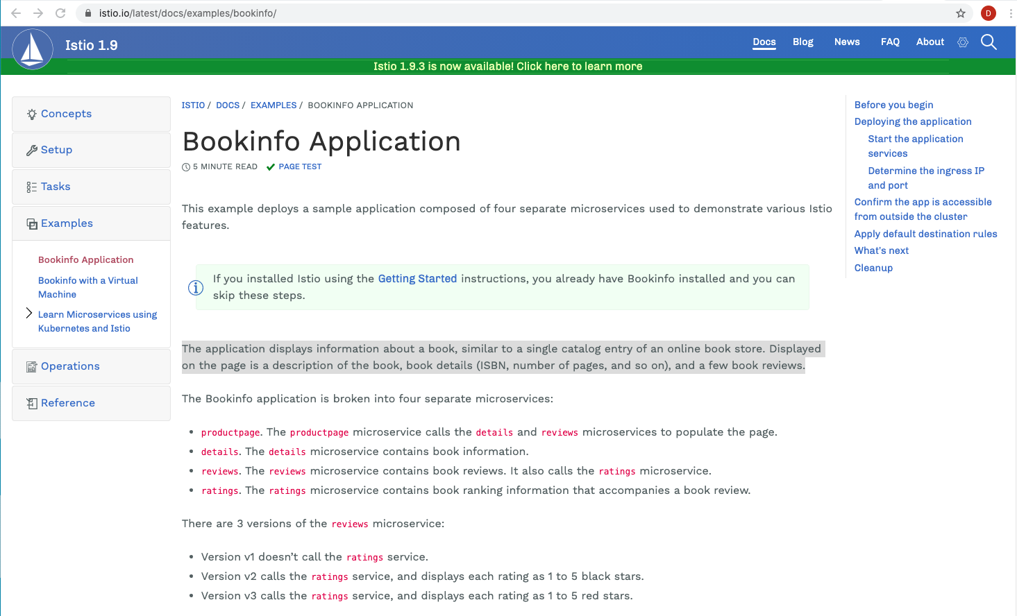

#deploy the sample application

% kubectl apply -f samples/bookinfo/platform/kube/bookinfo.yaml

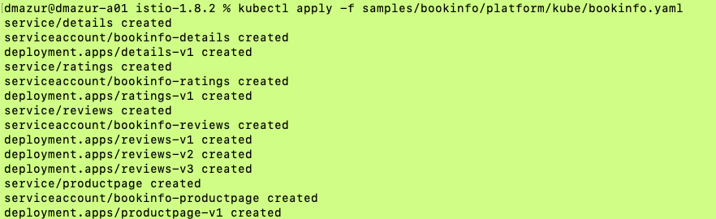

% kubectl get all

* Note: items highlighted in red were installed by the sample application

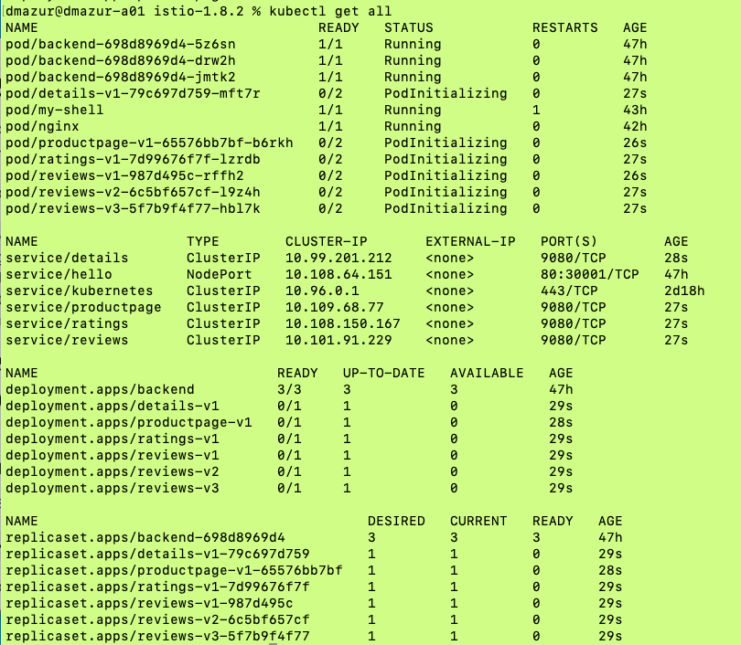



#the application is installed in the default namespace

% kubectl get all

#note: it takes a while (3-4minutes) for everything to initialize

% kubectl describe <use a pod from the get all>

#you can see the istio-proxy container that has been added as the sidecar container

#install gateway

#allows you to access the application via the browser

kubectl apply -f samples/bookinfo/networking/bookinfo-gateway.yaml



#apply default destination rules

kubectl apply -f samples/bookinfo/networking/destination-rule-all.yaml

#verify access

open browser to http://localhost:31080/productpage

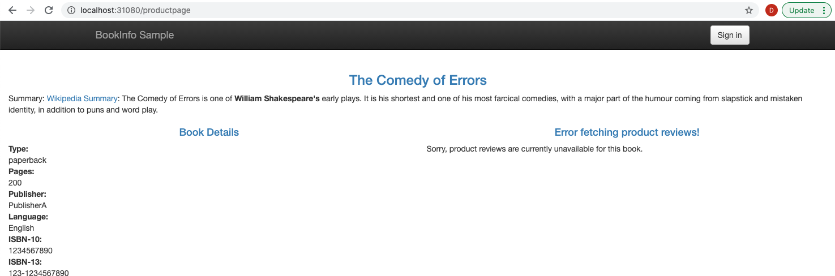

This next section install kiali.io which is a management console for istio-based service mesh.



#install kiali

% kubectl apply -f samples/addons

* Note: You will probably get the warnings below:

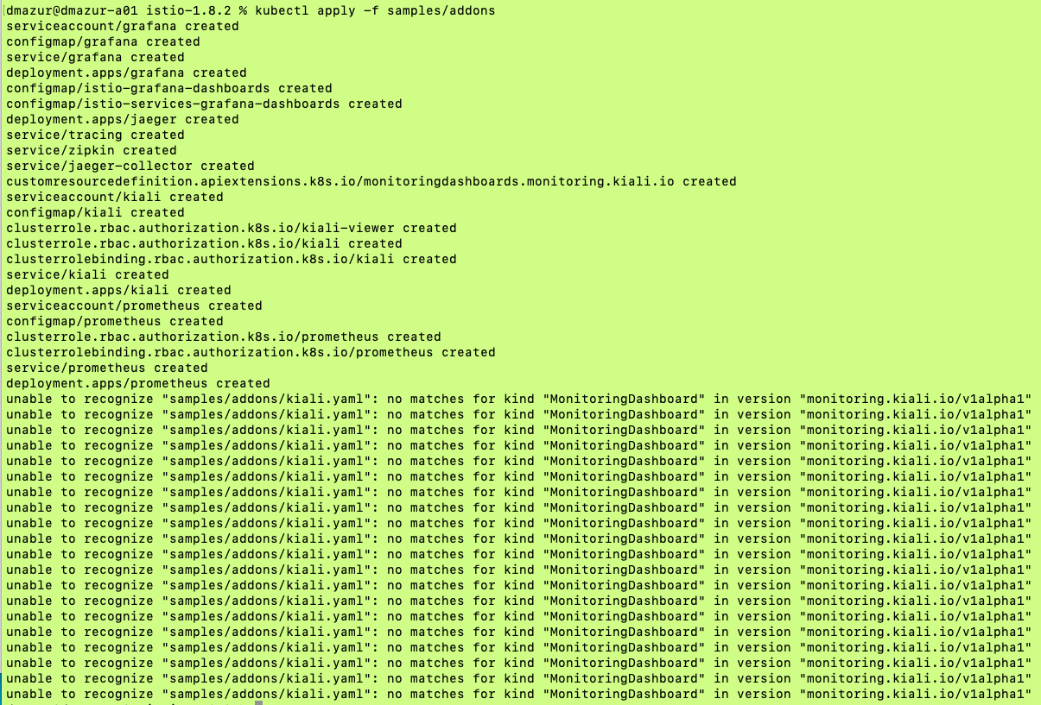



To clear up the warning, simply run the same command again:

% kubectl apply -f samples/addons

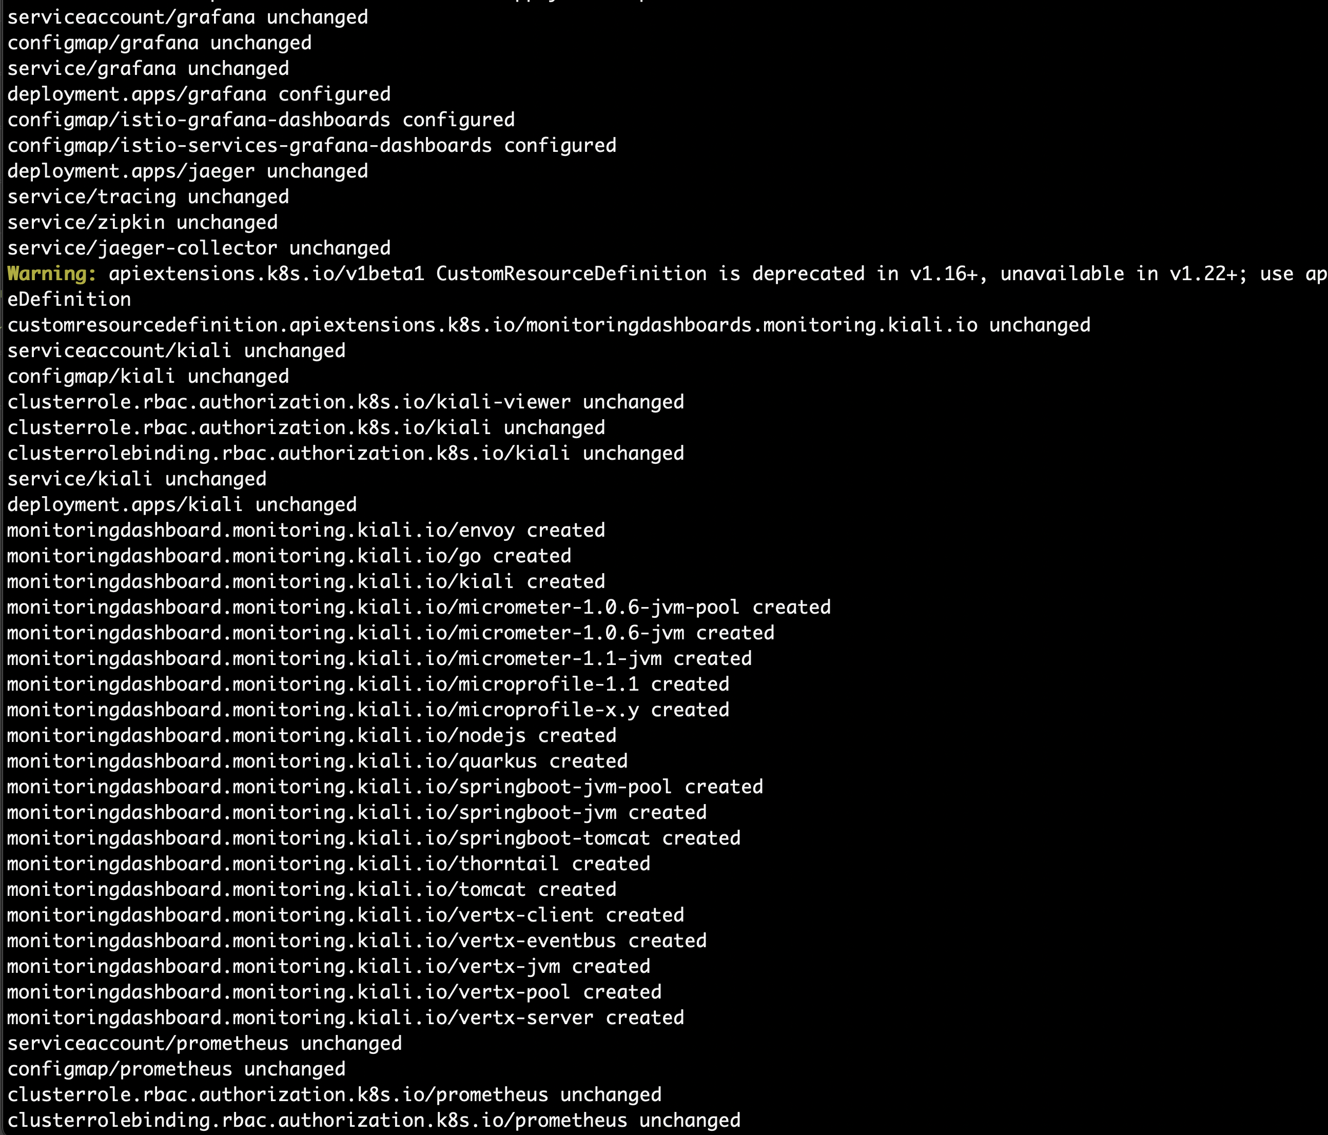

kubectl rollout status deployment/kiali -n istio-system



#access kiali

istioctl dashboard kiali

#demo service mesh

#note bookinfo example: https://istio.io/latest/docs/examples/bookinfo/

refresh the productpage multiple times - note how the ratings change as the

3 different ratings versions get called

#route all traffic to v1 version

#create VirtualService to route traffic:https://istio.io/latest/docs/tasks/traffic-management/request-routing/

kubectl apply -f samples/bookinfo/networking/virtual-service-all-v1.yaml

refresh productpage and note only v1 rating comes back

#cleanup

kubectl delete -f samples/bookinfo/networking/virtual-service-all-v1.yaml

#apply 50/50 virtual Service

kubectl apply -f samples/bookinfo/networking/virtual-service-reviews-50-v3.yaml

refresh productpage to verify a 50% mix to v1 and v3

#read through other traffic management options: https://istio.io/latest/docs/tasks/traffic-management/

**Extra practice (not really networking)**

Let’s try some concepts we learned in previous lessons. We are going to assign pods to specific nodes using node affinity and labels.

Let’s add labels to the worker nodes

% kubectl label nodes tamlab-worker nodetype=prod

% kubectl label nodes tamlab-worker2 nodetype=test

% kubectl get nodes –show-labels

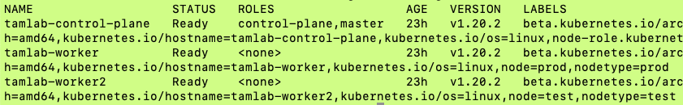



Now let’s create a pod. Here’s the yaml file:

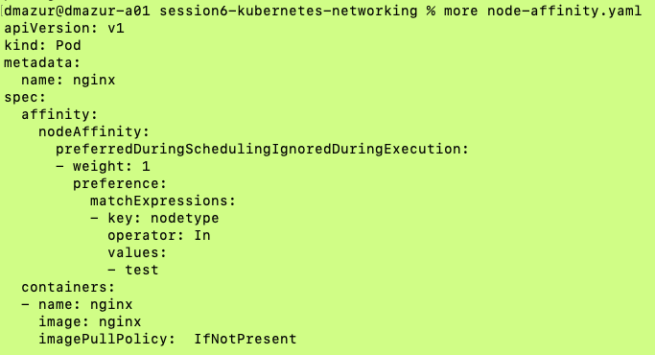



* If you look under “matchExpressions”, this yaml tells k8s to place the nginx container on a node with “nodetype=test”. We had previously added the label “test” to tamlab-worker2. Hopefully, that where the pod was placed. Let’s check

% kubectl get pods –output=wide

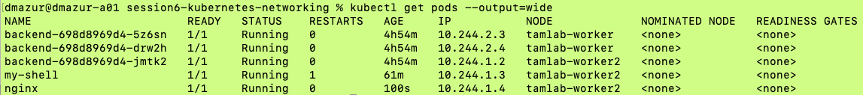



* Note: nginx is running on node tamlab-worker2 as expected!

**Clean up old clusters**

Delete tamlab cluster if it exists

% kind delete cluster --name tamlab